**Jesus loves me and gives me friends**

**Reading:** Mark 2:1-5, 11-12

A few days later, Jesus came back to Capernaum. The news spread that he was back home. A large crowd gathered to hear him speak. The house was so full that there was no place to stand, not even outside the door. While Jesus was teaching, some people brought a paralysed man to see him. But they could not get the man inside to Jesus because the house was so full of people. So they went to the roof above Jesus and made a hole in it. Then they lowered the mat with the paralysed man on it. When Jesus saw how much faith they had, he said to the paralysed man, “Young man, your sins are forgiven.”

Jesus said to the paralysed man, “I tell you, stand up. Take your mat and go home. Immediately the paralysed man stood up. He picked up his mat and walked out of the room. Everyone could see him. They were amazed and praised God. They said, “This is the most amazing thing we have ever seen!”

**Thought about the reading**

What amazing friends the paralysed man had! The paralysed man could not walk, but his friends knew that Jesus could help him. They wanted to get him into the house where Jesus was. Because they were such good friends, the man was healed, and he was able to walk home.

Jesus knows that friends are important. When we choose to follow him, we become part of his family, and we have lots of friends who are also Christians.

Jesus is the best friend of all. He loves us, and like the friends of the paralysed man, he helps us when we need help.

**Prayer**

Lord Jesus, thank you for our friends. Thank you that you give us friends to help us.

Thank you that you are the best friend I have.

Amen

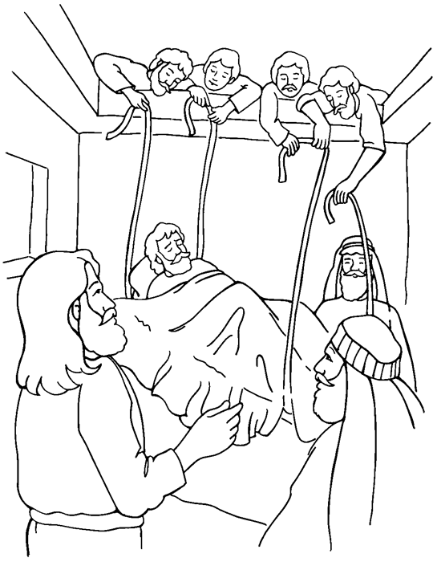

**Cambridge Causeway**

Autumn 2021

Bible Study notes

Jesus loves me and gives me friends

By Chrissy Cole